S S G M C E / C S E / 2 0 2 5 - 2 6 / Summer

Distributed Ledger Technology, Sub Code: 8KS04
TEC (Teaching Evaluation Component)

On
T i t l e

Centralized vs Decentralized System Simulation

Submitted By
(03) Devashree. U. Pundlik (65) Sarthak.M.Deshmukh
(66) Shantanu. R. Dongare (67) Shivam.A.Gahale

Final year, Eighth Semester
B.E. (Computer Science and Engineering)



Department of Computer Science & Engineering
Shri Sant Gajanan Maharaj College of Engineering, Shegaon – 444 203
2025-2026

1. Abstract

This project presents a simulation of centralized and decentralized systems using a money transfer model. It demonstrates how transactions are processed in traditional banking systems and blockchain-based systems.
The system compares performance, fault tolerance, and reliability. It also includes failure simulation and blockchain validation to provide a better understanding of Distributed Ledger Technology (DLT).

2. Introduction

Centralized systems are widely used in banking and financial services where a single authority manages all transactions. These systems are efficient but suffer from a single point of failure.
Decentralized systems distribute control among multiple nodes, improving reliability and transparency. However, they introduce complexity and slower processing.
This project simulates both systems to analyze their behavior and performance.

3. Objectives
- To simulate centralized and decentralized systems
- To compare speed, reliability, and fault tolerance
- To understand blockchain and consensus concepts
- To analyze system behavior during failures

4. System Architecture

Centralized System
- Single server handles all transactions
- Fast and simple
- Failure stops entire system
Flow:
User → Server → Process → Confirm

5. Methodology
The system is built using:
- Backend: Python (Flask)
- Frontend: HTML, CSS, JavaScript
Process:
- User inputs transaction
- System processes based on selected mode
- Results displayed with processing time
- Failures can be simulated

6. Modules
Centralized Module
- Processes transactions via one server
- Simulates server failure
Decentralized Module
- Uses multiple nodes
- Implements majority voting
Blockchain Module
- Uses SHA-256 hashing
- Detects tampering
Utility Module
- Handles validation and timestamps

7. Working of System
Centralized:
- Processes transactions quickly (~10ms)
- Stops completely if server fails
Decentralized:
- Slower (~20–30ms)
- Works even if some nodes fail
- Stops only when consensus fails
This shows the trade-off between performance and reliability.

8. Results and Analysis
Parameter | Centralized | Decentralized
Speed | High | Moderate
Reliability | Low | High
Failure Handling | Poor | Strong
Complexity | Low | High

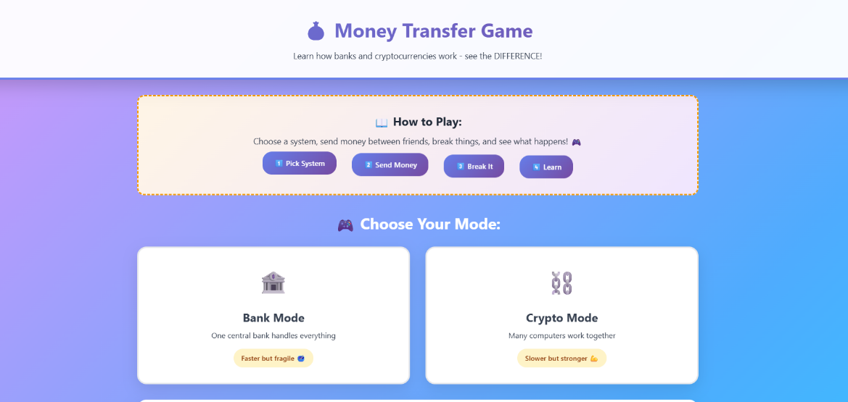
Main Interface
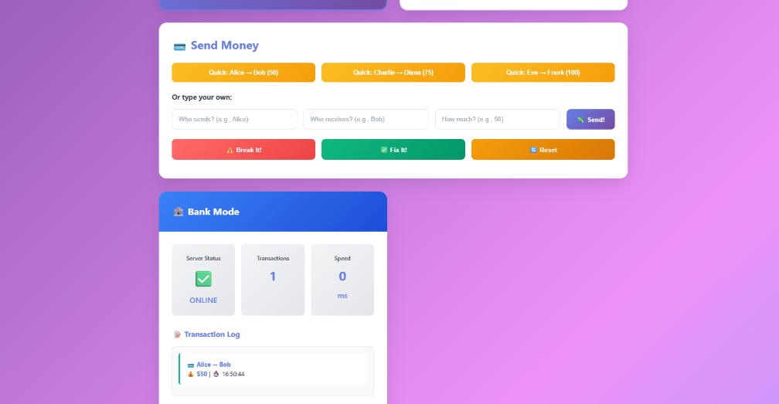
Centralized System

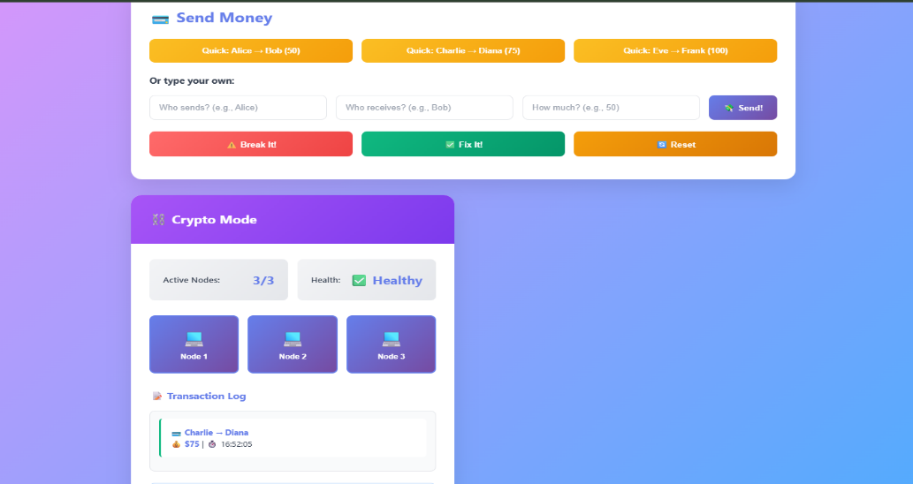
Decentralized System

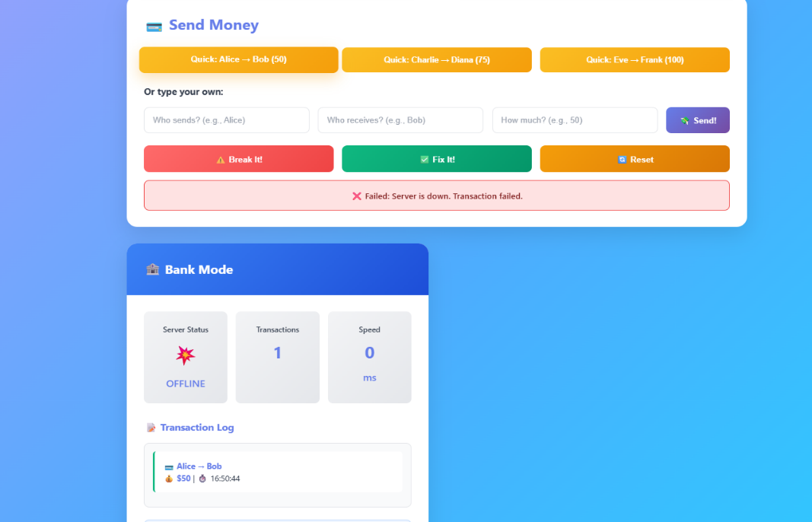
System Failed

10. Future Scope

- Integration with real blockchain APIs
- Implementation of Proof of Work / Proof of Stake
- Multi-user authentication system
- Database integration (MongoDB/PostgreSQL)
- Real-time network simulation
- Smart contract support

9. Conclusion
The project demonstrates the differences between centralized and decentralized systems. Centralized systems are fast but vulnerable, while decentralized systems are more secure and fault tolerant but slower.

The simulation helps in understanding real-world blockchain concepts.

